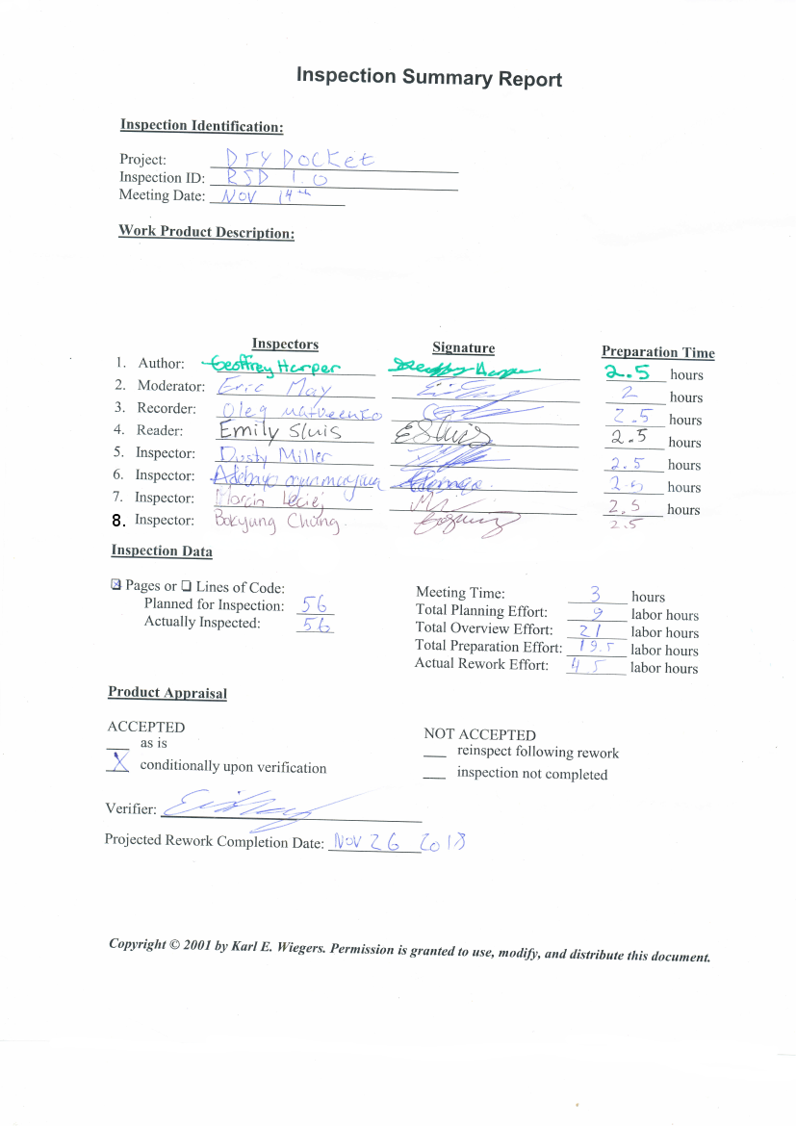

**Requirements Specification Document**

**DryDocket**

**New Spaghetti Factory**

**November 7th, 2018**

Client document wide comments:

Client comments done in red, highlights in yellow or green

It has been discussed between designers and client that there is a distinction between parts and designs in the ERP.

* Parts are purchased off the shelf (a bolt, for example)
* Designs are something that SpeedyBoats has designed. For example, a rod-holder that is manufactured from sheet metal (and labour). The rod-holder may be installed on many boats
* To take this notion further, a boat is also a design. And designs can contain parts and/or designs

The designs are the source of most information in Quotes and Work Orders. To illustrate the point via a simplified example:

If a client wishes to get a quote for a vessel consisting of a T220 hull, dual 350HP Yamaha outboard motors, 6 rod holders, a standard set of helm components (radios, steering mechanism, throttle control, various electrical toggles for lights/indicators, etc) and 4 standard seats you may see a quote put together as follows:

Quote #1234

* T220 standard hull (a design)
* 2 x Yamaha 350HP motors (parts)
* Standard helm components (a design consisting of a set of parts)
* 4 x standard seats (parts)

What I’m trying to demonstrate here is the way designs (and parts) become the source of information on Quotes and Work Orders. I would recommend that a precondition be added to the use cases ‘Create Quote’ and ‘Create Work Order’ along the lines of ‘relevant designs and parts have been entered into the system’ to indicate this.

Need to elaborate on uses of the word ‘User’/actor/engineer in the document. It is not always clear which user is being specified. Specific instances of this ambiguity have been noted in the document comments but this is an overall issue in the document itself. Be consistent, either reserving user for after actor has been defined(example add user to glossary User refers to any possible actor in a use case.)

* General document-wide comment: Since roles can be modifiable, perhaps change instances of ‘management or engineer can change/access this’, just state “users with relevant permissions”.
* In Sections 4 and 5, there are some redundant titles. Example:
  + **4.1.1 - Interface Accessibility**
  + **EI1**
  + **TITLE: Interface Accessibility**

Consider reducing the redundancy of the section labelling

**Revision History** **3**

**1 Introduction** **4**

1.1 Purpose 4

1.2 Project Scope 4

1.3 Glossary of Terms 4

1.4 References 6

1.5 Overview 6

**2 Overall Description** **6**

2.1 Product Perspective 6

2.2 Product Features 6

2.3 User Classes and Characteristics 7

Accounting 7

Management 7

Sales 7

Engineering 7

Purchasing 7

2.4 Operating Environment 8

2.5 Design and Implementation Constraints 8

2.6 Assumptions and dependencies 8

**3 DryDocket Features** **8**

3.1 Data Access/Organization 8

3.1.1 Description and Priority 8

3.1.2 Functional Requirements 9

3.1.2.1-SEARCH 9

View Sales Quote 9

View Work Order 11

View After Action Report 13

Build Step 15

3.1.2.2-STORAGE 17

3.1.2.3-BACKUP 17

3.1.2.4-DOCUMENT-CREATION 17

Create Quote 18

Create Work Order 19

Create After Action Report 21

Edit Form Fields 23

3.2 Automated Document Generation 25

3.2.1 Description and Priority 25

3.2.2 Functional Requirements 25

1- AUTOFILL 25

3.3 Log-In/Out 27

3.3.1 Description and Priority 27

3.3.2 Functional Requirements 27

1-LOGIN 27

Login 27

3.4 Profile Management 29

3.4.1 Description and Priority 29

3.4.2 Functional Requirements 29

Update Customer Profile 30

Add Customer Profiles 31

Add Employee Profiles 32

Edit Employee Profiles 33

3.5 Files Upload 35

3.5.1 Description and Priority 35

3.5.2 Functional Requirements 35

Upload Engineering Documents 35

3.6 Inventory 37

Resupply Inventory 37

Check Inventory 38

Use Inventory Item 39

**4 External Interface Requirements** **41**

4.1 User Interfaces 41

4.1.1 Interface Accessibility 41

4.1.2 Interface Dropdown Menus 41

4.1.3 Previous Order Template 41

4.2 Hardware Interfaces 41

4.3 Software Interfaces 42

4.3.1 Backup Data Export 42

4.4 Communications Interfaces 42

4.4.1 Email Communication 42

**5 Other Non Functional Requirements** **42**

5.1 Performance Requirements 42

5.1.1 Concurrent Connections 42

5.1.2 Form Access Time 43

5.1.3 Database Search Query 43

5.1.4 Employee Profile Creation Usability 43

5.1.5 Employee Permission Changes 43

5.1.6 Form Autofill 44

5.2 Safety Requirements 44

5.2.1 Previous Interface Backup System 44

5.2.2 Off-Site Backup 44

5.2.4 Unique Backup File 45

5.3 Security Requirements 45

5.3.1 Part Diagram Access Permissions 45

5.3.2 Gaining Access to DryDocket 45

5.3.4 Captured Data Confidentiality 45

5.3.5 File Deletion 46

5.3.6 Role Management 46

5.3.7 True Cost Analysis 46

5.4 Software Quality Attributes 47

5.4.1 Application Portability 47

5.4.2 Availability During Updates 47

5.4.3 DryDocket Failover 47

**6 Additional Requirements** **48**

**7 Analysis Models** **48**

7.1 Use Case Model 49

7.2 Entity Relationship Diagram 50

7.3 Data Flow Diagrams 51

7.3.1 [DFD 0] 51

7.3.2 [DFD 1] 52

7.3.2 [DFD 2] 53

7.4 Data Dictionary 54

**Appendix: Issues List** **56**

## 

## **Revision History**

|  |  |  |  |
| --- | --- | --- | --- |
| Name | Date | Reason for Changes | Version |
| Initial Release | October 30, 2018 | For client review | 0.9 |
| Formal Release | November 7. 2018 | Response to client feedback from version 0.9 | 1.0 |
|  |  |  |  |

## 

## 1 Introduction

### **1.1 Purpose**

The replacement sought by SpeedyBoats, hereafter referred to as "DryDocket", is an Enterprise Resource Planning system (hereafter, "ERP") that is used to track and manage orders, inventory, labour time, and documents. DryDocket reduces administrative work while increasing estimated cost accuracy.

The RSD describes an in-depth specification of DryDocket.

### **1.2 Project Scope**

DryDocket assists in many of the product manufacturing stages. It increases efficiency between these steps by decreasing the need to complete trivial tasks such as data entry, and inventory and data management. DryDocket also aims to increase overall cost accuracy by providing functions to monitor input costs to a project including labour time and materials.

### **1.3 Glossary of Terms**

|  |  |
| --- | --- |
| RSD | Requirement Specification Document |
| DFD | Data Flow Diagram |
| ERP Mentioned twice | Enterprise Resource Planner/Planning system. A management tool to aid in the tracking of products and work in a workplace. Including but not limited to, inventory management, time tracking and/or scheduling, and the information of Employee and/or Customer profiles. |
| RHIB | Rigid Hull Inflatable Boat |
| ERP | Short for “Enterprise Resource Planning”. Software for a business to help the company manage resources such as raw materials, labour, designs, etc. |
| True Cost | The cost of products before markup. |
| User-Class | A representation of a type of user. Contains the permissions/authorization the user has for interacting with or viewing other data in DryDocket. |
| Preliminary Work Order | A Work Order that does not contain information regarding inventory availability and work logs. |
| RD | Requirements Document |
| Failover | Switching to a [redundant](https://en.wikipedia.org/wiki/Redundancy_(engineering)) or standby [computer](https://en.wikipedia.org/wiki/Computer) [server](https://en.wikipedia.org/wiki/Server_(computing)), [system](https://en.wikipedia.org/wiki/System), hardware component or network upon the failure or [abnormal termination](https://en.wikipedia.org/wiki/Abnormal_end) of the previously active [application](https://en.wikipedia.org/wiki/Application_software), server, system, hardware component, or network. |
| MUST | This word, or the terms "REQUIRED" or "SHALL", mean that definition is an absolute requirement of the specification.  BCP 14 [https://tools.ietf.org/html/bcp14] |
| MUST NOT | This phrase, or the phrase "SHALL NOT", mean that the definition is an absolute prohibition of the specification.  BCP 14 [https://tools.ietf.org/html/bcp14] |
| SHOULD | This word, or the adjective "RECOMMENDED", mean that there may exist valid reasons in particular circumstances to ignore a particular item, but the full implications must be understood and carefully weighed before choosing a different course.  BCP 14 [https://tools.ietf.org/html/bcp14] |
| SHOULD NOT | This phrase, or the phrase "NOT RECOMMENDED" mean that there may exist valid reasons in particular circumstances when the particular behavior is acceptable or even useful, but the full implications should be understood and the case carefully weighed before implementing any behavior described with this label.  BCP 14 [https://tools.ietf.org/html/bcp14] |
| MAY | This word, or the adjective "OPTIONAL", mean that an item is truly optional. One vendor may choose to include the item because a particular marketplace requires it or because the vendor feels that it enhances the product while another vendor may omit the same item. An implementation which does not include a particular option MUST be prepared to interoperate with another implementation which does include the option, though perhaps with reduced functionality. In the same vein an implementation which does include a particular option MUST be prepared to interoperate with another implementation which does not include the option (except, of course, for the feature the option provides.)  BCP 14 [https://tools.ietf.org/html/bcp14] |
| DESC | Description |
| RAT | Rational |
| DEP | Dependency |

WHile the last three explain the acronyms, I would find it helpful to also include their meaning in the context of its respective section

### 

### **1.4 References**

[1] Speedy Boats. (2018). [online] Available at: https://speedyboats.wordpress.com/

[Accessed 19 Sep. 2018].

[2] Bradner, S. (1997). *Key words for use in RFCs to Indicate Requirement Levels*.

[online] Best Current Practice. Available at: https://tools.ietf.org/html/bcp14 [Accessed 20 Sep. 2018].

[3] Bray, Ian K. (2002). An Introduction to Requirements Engineering. Essek, UK:

Pearson Education Ltd.

[4] E2 Shop System Manual. https://client.shoptech.com/faq/manuals/reference.pdf.

### **1.5 Overview**

This specification contains and describes all of DryDocket's features, actor use cases, data flow diagrams, and projected development plans. External interface requirements, the user interaction with DryDocket, and other non functional requirements (safety, performance, quality assurance, and security requirements). Check sentence structure (Sentence fragment)

## **2 Overall Description**

### **2.1 Product Perspective**

DryDocket replaces the current *E2 Shop System*[4] currently being used at SpeedyBoats. It is a self contained product that does not interface with other software systems. However, DryDocket offers a variety of export formats for data. DryDocket is not a member of a larger software suite. It is not used at every step of the manufacturing process, but often consulted by employees to view or update Work Orders, Customer or Employee information, inventory, or schedules.

### **2.2 Product Features**

DryDocket features include inventory, Work Order, and financial management; attaching arbitrary documents to inventory and Work Orders; logging employee labour time; managing customer and employee information; generation of After Action Reports; and full text search of all information in DryDocket.

All forms will attempt to use autocomplete to increase the productivity of data entry tasks. All form fields are flexible, and can be renamed, added, or removed as needed. Repetition is avoided by allowing the duplication of existing documents.

A user-class permission model ensures security of sensitive information such as customer and employee profiles, price quotes, After Action Reports, or financial information.

### 

### **2.3 User Classes and Characteristics**

DryDocket supports arbitrary user classes and their associated permission (see *Glossary of Terms* as needed). The default user classes shipped with DryDocket are Accounting, Management, Sales, Engineering, and Purchasing. User classes can be modified, removed, or added by a member of the management user class; see Figure 35. Each user class has a different security clearance defined by a set of permissions for what documents the user class member may uploads,(and) what interfaces of DryDocket the user class member may access or modify.

Below the default user classes are explained.

#### Accounting Each of these user classes could probably use section headings to be easily revisited/referred to later (Ie 2.3.1, 2.3.2…).

#### Each of these paragraphs begins with a sentence fragment. Change to bullet points or complete sentences.

Maintains records of financial transactions by establishing accounts; posting transactions; and ensuring legal requirements compliance. Bookkeepers have access to input and retrieve data pertaining information about all prior product sales, as well as input costs for accounting and tax auditing purposes.Bookkeeper is only mentioned here, add to glossary or change bookkeeper to whatever user class this is referring to

#### Management

Administrative access to all aspects of DryDocket. Able to view and modify each interface of DryDocket, as well as all of its contained data. Management will act as the administrator and have the authority to view and edit all employee profiles.

#### Sales

Ability to create Sales Quotes and profiles for Customers, access all previous records of product sales, and have information about manufacturing input costs. Sales are able to create and modify Customer profiles.

#### Engineering

Unrestricted access to inventory items and Work Orders. Able to upload, search, and view documents in the categorized inventory database of files.(Is this just the database?)

#### Purchasing

Allows access to create and manage purchase orders and quotes from suppliers. This includes supplier contact management, and the ability to edit fields for forms that are related to the purchaser user class. Provides administrative access to the inventory, which allows changes to inventory cost, quantity, and the management of items. Flagged for later; are forms later listed with regards to the user class that uses them

### 

### **2.4 Operating Environment**

DryDocket will be a locally hosted web application run on a computer in the shop. The frontend of the application which runs in the internet browsers of the computers of the users in the shop, supports browsers from 2015 and later regardless of operating system.

Due to the nature of web applications DryDocket does not need to consider other applications on the users' computers - all browsers supply sufficient isolation.

### **2.5 Design and Implementation Constraints**

In RD 1.0, the proposed ERP system had a requirement of interfacing with barcode scanners. Since then the requirement has been lifted, which allows for DryDocket to be implemented as a web application since it does not need to interface with USB or Bluetooth devices. However, until web USB and/or web Bluetooth support reach mainstream browser support, the future introduction of features which use those protocols will be constrained. Web browsers do have USB support (you can use your webcam devices with many existing websites)

Additionally, the SpeedyBoats team to be using DryDocket use English as their only language of business. Therefore, further localization will not be considered.

In the RD 1.0 document critique by SpeedyBoats, it was stated that the team has an existing offsite backups solution - this imposes a constraint to the design of DryDocket's backup mechanism. Clarify the constraint (eg: must be utilize SpeedyBoats’ existing backup system)

### **2.6 Assumptions and dependencies**

DryDocket assumes the existing backup software will either offer a server to interface with or support backing up files left in specific locations by the DryDocket server. There needs to be some form of communication for backups to function.

DryDocket is will be built with a flexible authentication module that supports many strategies for signing in. It is assumed that SpeedyBoats will want to use a supported strategy such as:

* Username or email login combined with any of:
  + Password, or This should be a semicolon
  + Passwordless email sign in link.

## **3 DryDocket Features**

### **3.1 Data Access/Organization**

#### **3.1.1 Description and Priority**

Users of the software will often need to access files in a quick and efficient manner that does not hinder their productivity. This functionality will be given a *high* priority.

#### 

#### **3.1.2 Functional Requirements**

##### **3.1.2.1-SEARCH**

Search functionality to access the following information Should include a must somewhere since these are functional requirements, as per glossary

* Purchase Records
* Parts/Materials Suppliers
* Parts/Materials Pricing and Availability for each Company
* Engineering Documents
* Sales Quotes
* Work Orders
* After Action Reports
* Customer Profiles
* Employee Profiles

###### View Sales Quote (Each use case needs a header explaining that this is the beginning of the use cases i.e. 3.1.2.2-Associated Use Cases)

Summary: View a Work Order(Inconsistent with title)

Actors: All

Pre-conditions:

* User has logged in.

Post-conditions:

* None

Basic Flow:

* The actor searches for a Sales Quote. Should choose a term: user or actor, not both
* The actor examines the Sales Quote.

**Figure 1:** Searching for a Sales Quote

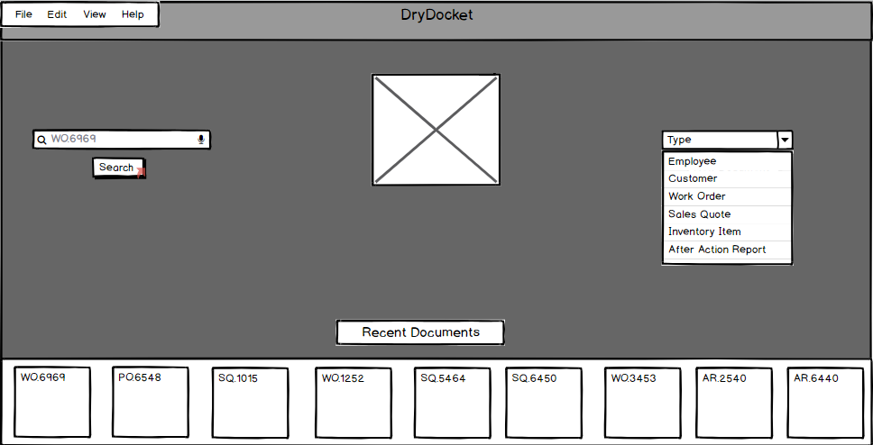

Here a Sales Quote can be searched for by using the search bar on the left or if the document has been recently opened by the user it will appear on the carousel at the bottom and the user can click on it to be taken to that document.

**Figure 2:** Example Sales Quote

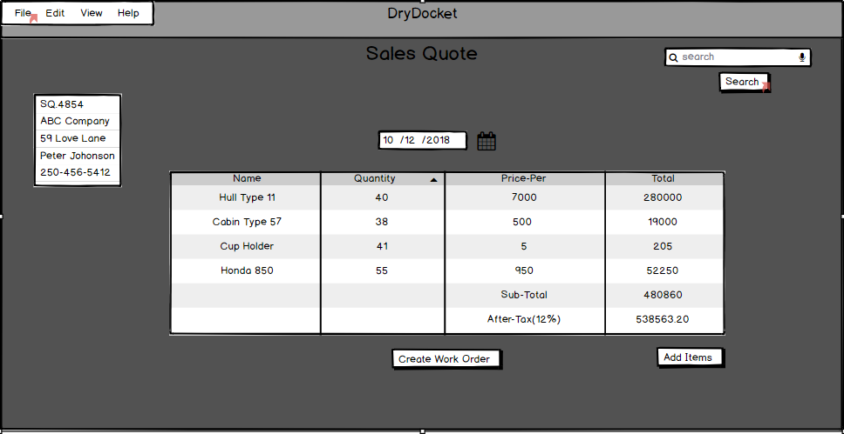

This Sales Quote screen is what the user will see once they successfully search for and open up a previous Sales Quote (see Fig. 1). If the user wishes to export the quote to a pdf, email or as a .csv file they may open up the File menu in the top left corner and click on share in the dropdown menu. If the user wishes to search for a particular part to add to the quote they may use the search bar in the top-right. If they wish add an item from a list of items they may click the add items button. Once they have determined the Sales Quote is finished they may click Create Work Order.

**Figure 3:** Sequence Diagram View Quote

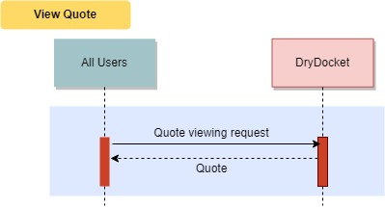

###### View Work Order

Summary: View a Work Order

Actors: All

Pre-conditions:

* User has logged in.

Post-conditions:

* None

Basic Flow:

* The actor searches for a Work Order. User/actor
* The actor examines the Work Order.

**Figure 4:** Searching for a Work Order



Here a Work Order can be searched for by using the search bar on the left or if the document has been recently opened by the user it will appear on the carousel at the bottom and the user can click on it to be taken to that document.

**Figure 5:** Example Work Order

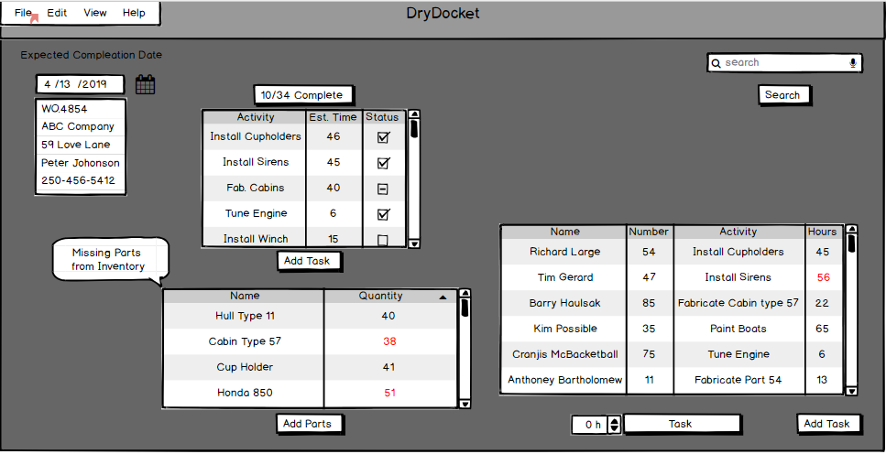

This is an example of a inprogress Work Order.The top table displays the tasks associated with this Work Order.The far right column displays the status of the task a check is a completed task, a dash is in progress and an empty box hasn't been started.The left table display recent progress made by the Engineers on the assigned task a red number represents the task took longer than anticipated. The buttons on the bottom left are used to record time spent on tasks. Grammar check or switch to point form

**Figure 6:** Sequence Diagram View Work Order

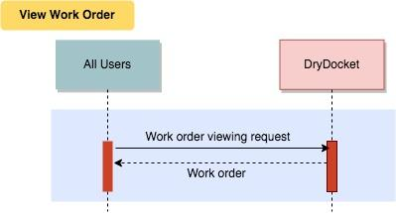

###### 

###### View After Action Report

Summary: View After Action Report

Actors: Accounting

Pre-Conditions:

* The User has logged in.

Post-Conditions:

* None.

Basic Flow

* An Accounting team member searches for an After Action Report.
* The Accountant views the After Action Report.

**Figure 7:** Searching for a After Action Report

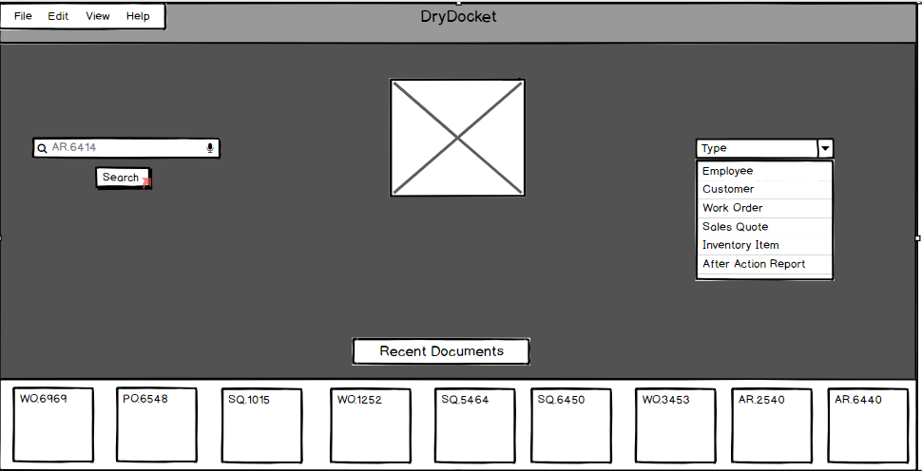

Here a Sales Quote should match title above can be searched for by using the search bar on the left or if the document has been recently opened by the user it will appear on the carousel at the bottom and the user can click on it to be taken to that document.

**Figure 8:** Example After Action Report:

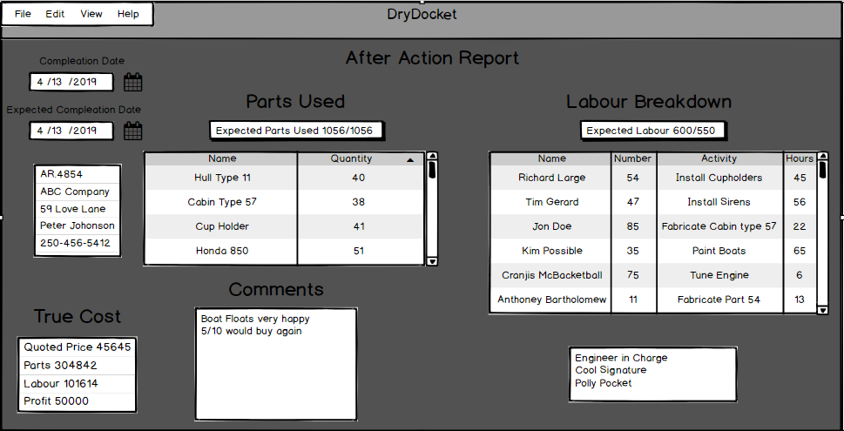

This is an example of an After Action Report.The true cost(glossary term - capitalize) is the Cost (not defined in glossary - should not be capitalized) before markup on inventory items.This is used to calculate profits.It also displays the expected amount of hours to complete the Work Order vs the actual amount of hours.

**Figure 9:** Sequence Diagram View After Action

### 

###### Build Step

Summary: Mark a step of a Work Order as complete.

Actors: Engineers

Pre-conditions:

* Work Order step must need to be completed.
* The User has logged in.

Post-conditions:

* Work Order step is marked as complete.
* The calendar has a work log event created for the relating build and the Engineer. (is this indicating that an engineer completes work steps? A fabricator/welder actually completes work steps)

Basic Flow:

* Engineer may optionally mark the start of work logging for the build step.( Does the engineer mark the work log ??)
* The *<<Include "Use inventory" >>* is used as needed throughout the build.
* After the build, the build step is marked as completed in Work Order form.
* Hours worked by the Engineer are logged in Work Order form.

**Figure 10:** Work Order with Recently Added Parts

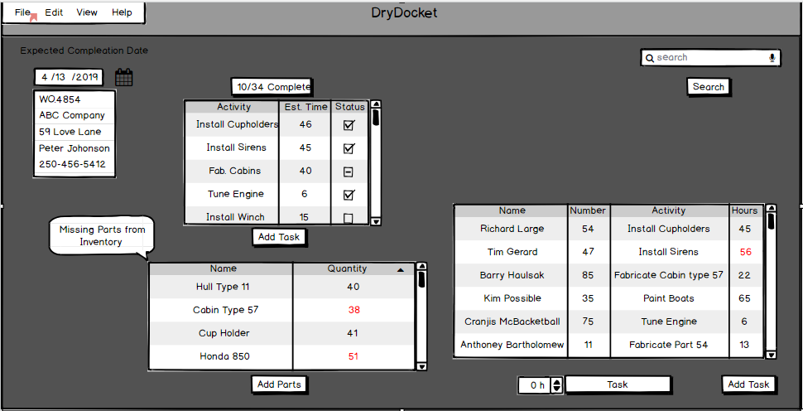

See Figure 5. For Work Order Description.

Just copy/paste that description here. Going up 5 pages to read the description significantly affects readability

**Figure 11:** Sequence Diagram Build Step

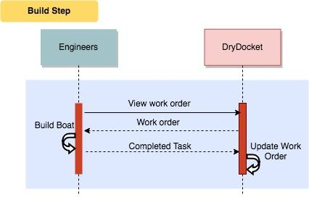

##### 

##### 

##### 3.1.2.2-STORAGE

Files must be stored in an organized fashion that:

* Allows for easy access through a file DryDocket; and
* Can be discovered through a search query.

##### 3.1.2.3-BACKUP

A backup storage DryDocket must be in place to allow access to previous versions of documents, as well as restore DryDocket in the event the main storage system encounters errors.

This backup system MUST(2) be compatible with SpeedyBoats(1) current backup suite. (1) SpeedyBoats’ (2) lowercase, nowhere else is UPPER used for must

**Figure 12:** Backup Interface

This is the interface used to modify the backup properties.It is accessed through clicking the file tab. Here the location of the backup file can be changed or seen. The frequency of the can also be adjusted to set values.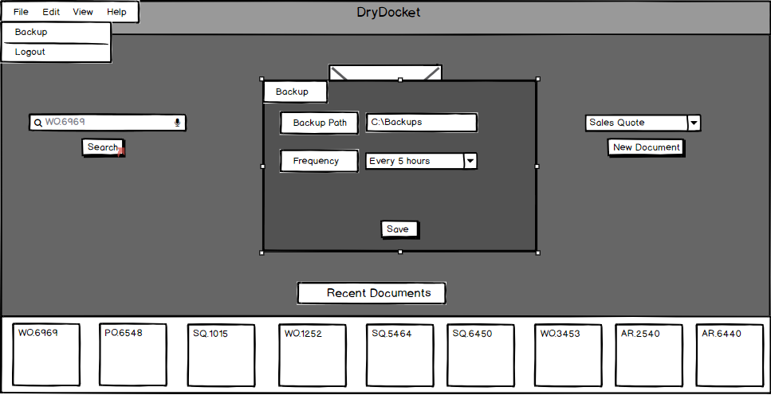

##### 3.1.2.4-DOCUMENT-CREATION

DryDocket supports the creation and editing of Sales Quotes, Work Order, After Action Reports, and Inventory Items.

###### 

###### Create Quote

Summary: Allows Sales to give customers a projected cost for the manufacturing of a boat this is NOT something you want to tell the customer

Actors: Sale sales

Pre-Condition:

* There is a request for a boat to be built.
* The User is logged in.

Post-Condition:

* Customers will decide if they accept the cost of their boat build.
* A Sales Quote is added to DryDocket.

Basic Flow:

* Request for boat build arrives from customers with product specifications.
* Merchandise is added to the quote to match specifications.
* Estimated prices are sent to customers. As mentioned above, this cost should not be the estimate price of labour+parts, it should be whatever sales decides to charge for it
* Customers decide to accept or negotiate cost and specifications their wanted product.
* Price is finalized, on to the next step of production. Ambiguous. Perhaps mention that a work order is created?

**Figure 13:** Example Quote

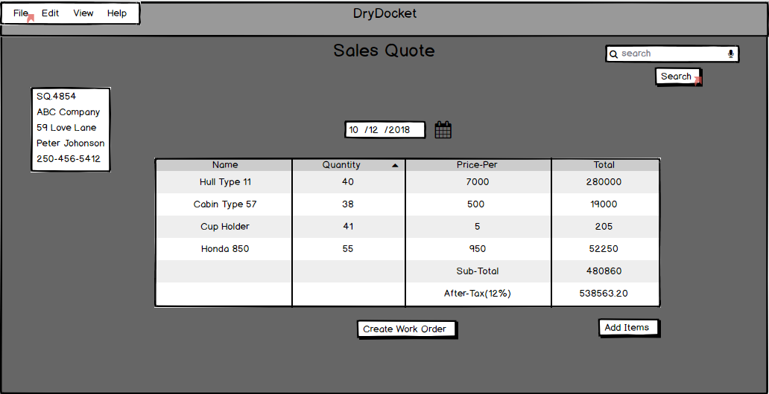

See Figure 2. For Sales Quote description

Just copy/paste that description here. Going up pages to read the description significantly affects readability

**Figure 14:** Sequence Diagram Create Quote

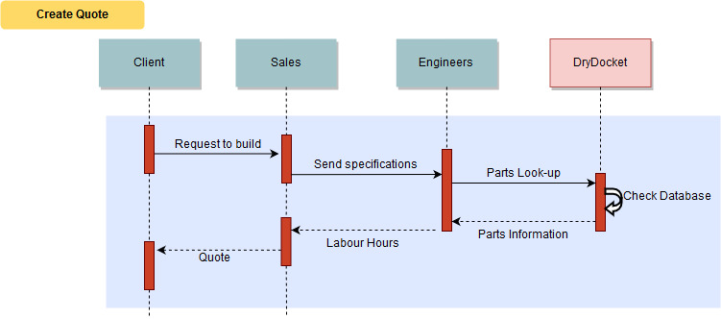

###### Create Work Order

Summary: Allows Engineers to create Work Orders

Actors: Engineers

Pre-conditions:

* A Sales Quote has been created and agreed on by the Customer.
* SpeedyBoats is ready to start manufacturing a boat.
* The User has logged in.(Who is the user?)

Post-conditions:

* A Work Order is created.
* The inventory will be modified. Use present tense as with the other bullet points
* The Customer's profile is updated.

Basic Flow:

*Note: All actions are performed by the Engineer* This is implied by the actor being engineers

* A Work Order document is created from a Sales Quote. Perhaps link to the use case that describes this flow for extra clarity
* The Customer's profile is updated to show the new Work Order.
* DryDocket changes inventory to reflect the parts used on this project.
* The amount of hours needed by workers to assemble the boat is estimated and added to the Work Order.
* A completion date for the Work Order is estimated and added.
* The Work Order is finalized, saved, and submitted.

**Figure 15:** Create Work Order

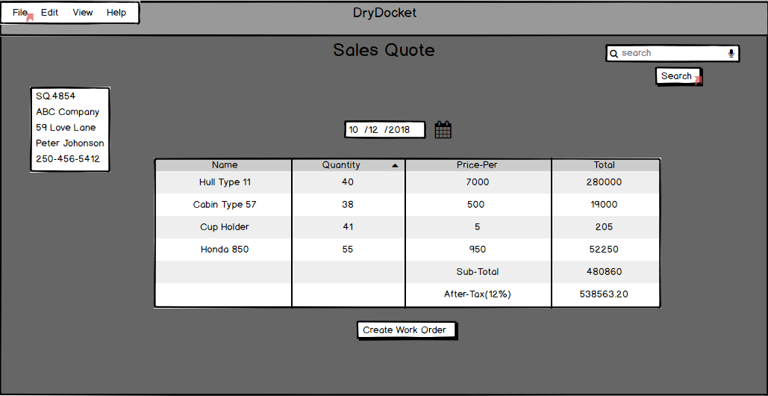

See Figure 2.For Sales Quote description. (Include description for readability)

**Figure 16:** Create an Empty Work Order

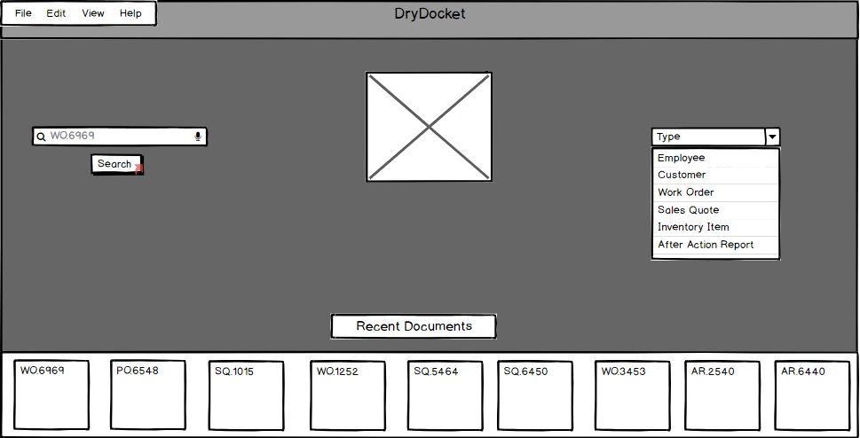

To create an empty document rather than generating, navigate to the main search screen then select the document type from the dropdown menu and select the create button currently hidden by the dropdown. It would be useful to actually see the element to click, even if it results in very similar UI screenshots

**Figure 17:** Sequence Diagram Create Work Order

### 

###### Create After Action Report

Summary: An After Action report is created This reads more as a post condition rather than a summary of the actions. Should be expanded to explain the flow better (see Slack)

Actors: Manager

Pre-Conditions:

* The User is logged in. Who is the User? A Manager?
* All tasks of a Work Order have been completed.
* The Merchandise has been delivered.

Post-Conditions:

* An After Action report is added to DryDocket.

Basic Flow:

* The Engineer searches for the completed Work Order.
* The Engineer verified and signed off that the Work Order is correct and complete.
* The Engineer selects the option to compute an After Action Report.
* DryDocket calculates profit, changes in labour estimates and parts used.
* DryDocket formats this data and enters it into the After Action Report.
* DryDocket adds the Engineers signature to the After Action Report.
* DryDocket saves and submits the After Action Report.

**Figure 18:** Example Work Order to Generate After Action Report

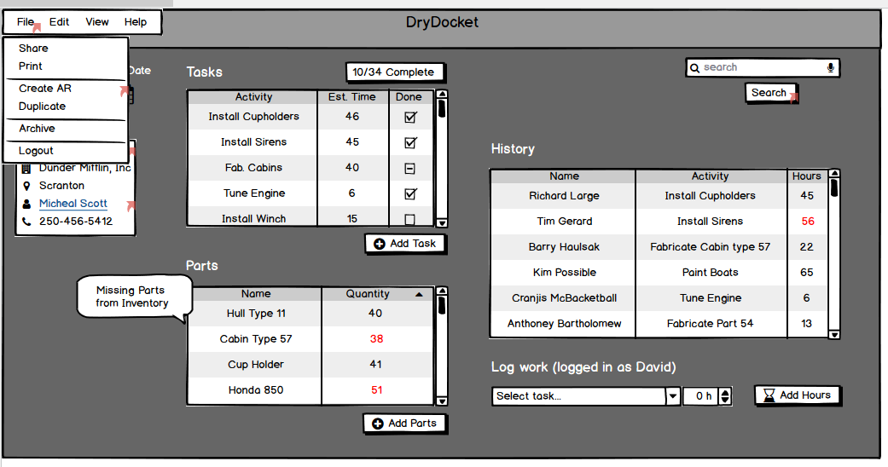

To generate a After Action Report a user with the Manager role would go to a complete Work Order select file then click create AAR.This would create a new document with all of the information taken from the Work Order.

**Figure 19:** Example Generated After Action Report



See Figure 8.for After Action Report description. (Include description for readability)

**Figure 20:** Create Empty After Action Report



To create a blank After Action Report navigate to the main search screen then select After Action Report and select the create button hidden by the dropdown.

**Figure 21:** Sequence Diagram Create After Action Report

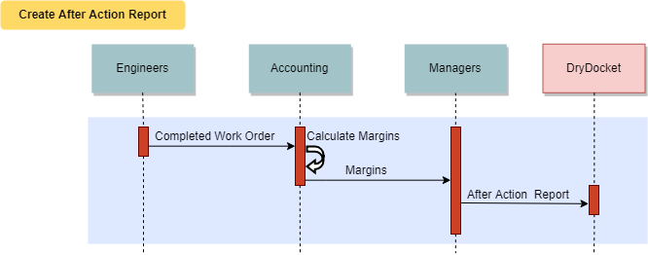

###### Edit Form Fields

Summary: Update the available fields for data entry forms

Actors: All

Pre-conditions:

* Must have an existing data entry form to modify.
* The User has logged in.

Post-conditions:

* All *future* documents that require data entry using that form will display the new fields. Existing documents are not updated.

Basic Flow: Direct and indirect haven’t been used elsewhere in the documents so consider removing them, combining them or defining them for document consistency.

* Direct:
* The actor is shown a list of existing forms in the ERM system to select. DryDocket
* The form is selected to be edited.
* Fields can be renamed, re-ordered, deleted, or created. There must be no duplicate fields for the form to be saved.
* The form is saved.
* Indirect
  + The form editing mode described above can be engaged while entering data in an existing form. The fields will be modified but the values will persist unless the field is deleted.
  + A confirmation dialog alerts the actor that their edits to the form fields, should they choose to save, will impact all future forms.
  + The form is saved, and the actor returns to data entry.

**Figure 22:** Example of Customizable Form

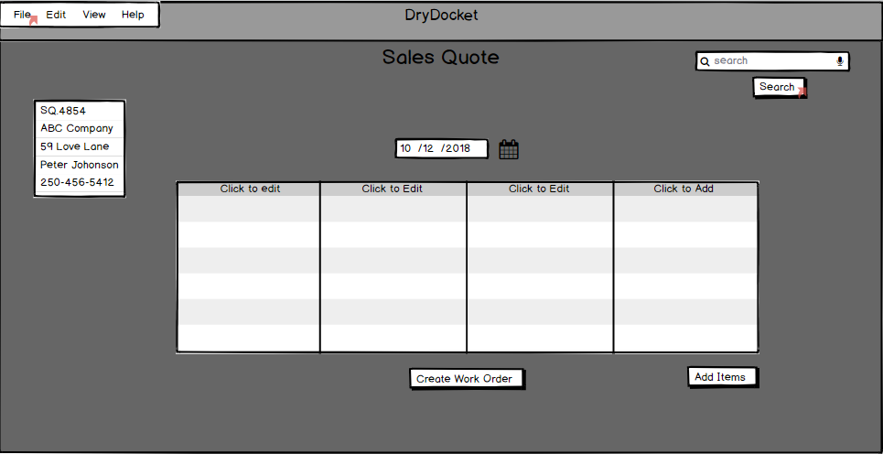

This is an example of a non-generated Sales Quote.Its column names can be edited by selecting the top cell and more columns can be added by clicking on the far right column.

More UI screenshots could make this easier to understand.

**Figure 23:** Sequence diagram for Edit Form Fields:

### 

### **3.2 Automated Document Generation**

#### 3.2.1 Description and Priority

The software will need to automate document creation process, and autofill duplicate contents without relying on additional user input.This functionality will be given *high* priority.

#### 3.2.2 Functional Requirements

##### 1- AUTOFILL

Software MUST be able to autofill duplicate contents:

* Work Orders can be partially generated from a Sales Quote so parts lists no longer have to be manually entered.
* After Action reports can be fully generated from Work Orders.

**Figure 24:** Generated Work Order



See Figure 5. For Work Order description.

**Figure 25:** Generated After Action Report

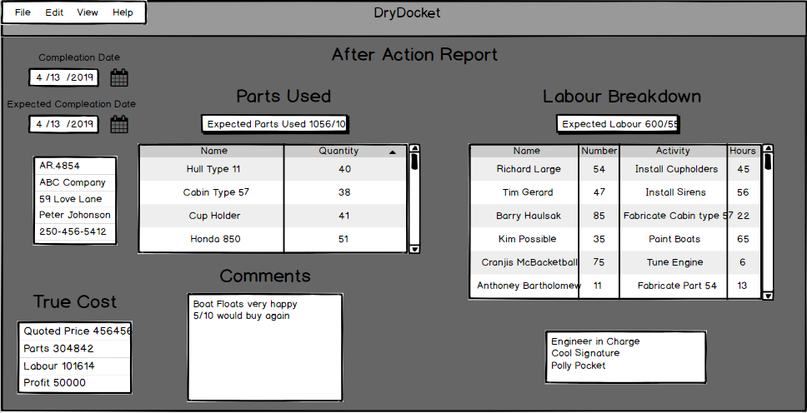

See Figure 8. For After Action Report description.

### 

### **3.3 Log-In/Out**

#### 3.3.1 Description and Priority

Users of the software will need to log in and out of their respective accounts. A secure system that monitors work-time must be used to enter and exit the software. This functionality will be given high priority. Are you integrating another system with the software, perhaps you meant “ a secure mechanism that monitors work time must be used within the software “ .

#### 3.3.2 Functional Requirements

##### 1-LOGIN

Users MUST be able to log in and out of their accounts:

* Through a secure process that MUST NOT compromise the privacy of their account and login information; and
* So that they can access the features designated for their user class.

###### Login

Summary: Users must log into their accounts to access or interact with any portion of the software.

Actors: Everyone Consider revising to “All User Classes except Customers”

Pre-condition:

* The User has a valid account in DryDocket.

Post-Condition:

* Will be able to access and interact with DryDocket.

Basic Flow:

* The users enter a employee number and password. Should be the user enters ...
* DryDocket verifies the credentials.
* The credentials are valid access is granted.

**Figure 26:** Launch Screen of DryDocket

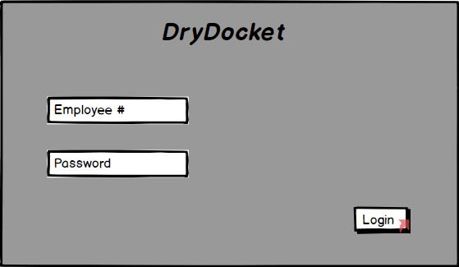

This is the screen that is displayed when the program is launched. The current authentication model requires the user to login with an employee number and a password.

**Figure 27:** Successful Login

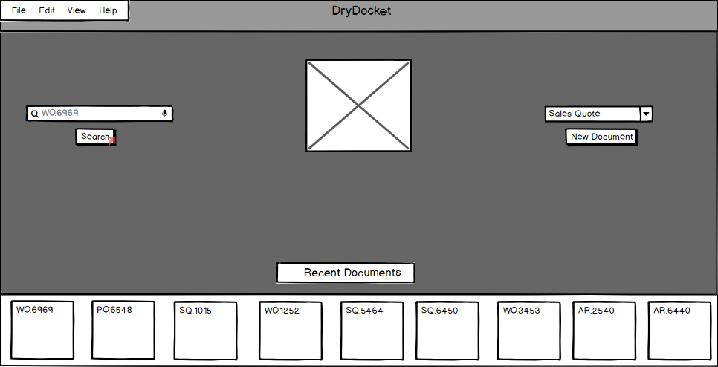

After a successful ogin the users is taken to the main search screen.This screen can be returned to by searching an empty search bar.

**Figure 28:** Unsuccessful Login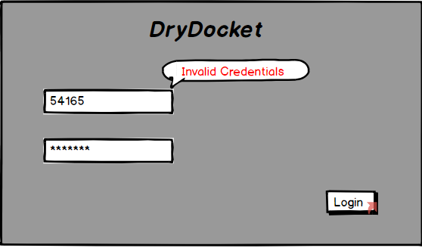

When a login fails, the user is notified by displaying an alert on the screen.

**Figure 29:** Sequence diagram of Login

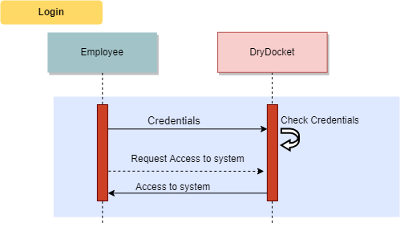

### **3.4** P**rofile** M**anagement**

#### 3.4.1 Description and Priority

Managers MUST be able to edit and manage Employee and Customer profiles. Furthermore, different access and operating permissions must be able to be set on each user.

#### 3.4.2 Functional Requirements

**1- MANAGE PROFILES**

Managers MUST be able to act as a high level administrator and be able to manage profiles including:

* Create new profile
* Edit existing profile
* Remove profile

**2- CUSTOM MEMBERSHIP PERMISSIONS (EMPLOYEES ONLY**)

Managers MUST be able to assign custom memberships and set different access permissions for members including:

* Financial information access and modify permission
* Purchase information access and modify permission
* Material costs access and modify permission
* Engineering profiles (Frame instructure, drawings etc.) access and modify permission
* Manufacturers information access and modify permission

###### Update Customer Profile

Summary: Entry of Customer information

Actors: Sales, Manager

Pre-conditions:

* The User has logged in.

Post-conditions:

* Information on the Customer profile is changed.

Basic Flow:

* The Customer profile is searched .
* Changes are made to the Customer information.
* The information is saved and submitted.

**Figure 30:** Customer Profile

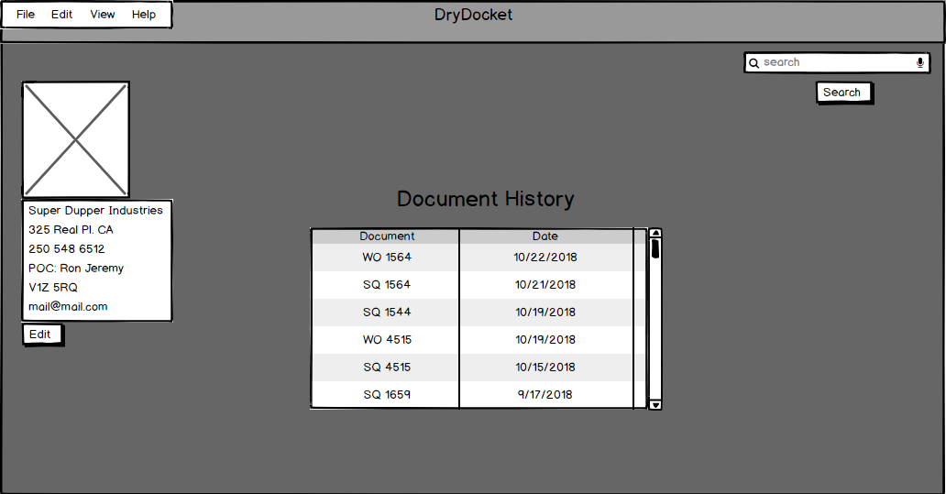

This is an example of a customer profile. It contains a list of all the documents that pertain to that customer along with basic information about them and a picture.

###### 

###### Add Customer Profiles

Summary: Allows the Sales to create Customer profiles.

Actors: Sales, Manager

Pre-conditions:

* Customer doesn’t exist in DryDocket.
* The User has logged in.

Post-Condition:

* New Customer profiles is added to DryDocket. Profile is/profiles are

Basic Flow:

This use case starts when a new Customer comes in and enables Sales to create an account by entering information that’s needed in the Customer’s profile. This should probably be moved to the summary to overall be more consistent with other use cases

Seems like there is a missing step for navigating to the add customer page

* Sales uploads the customer’s photo to DryDocket (optional).
* Sales inputs the Customer’s company name, POC name, address, postal code, email address, and phone number to DryDocket.
* DryDocket notifies that the customer profile has been created.

**Figure 31:** Document Creation Screen

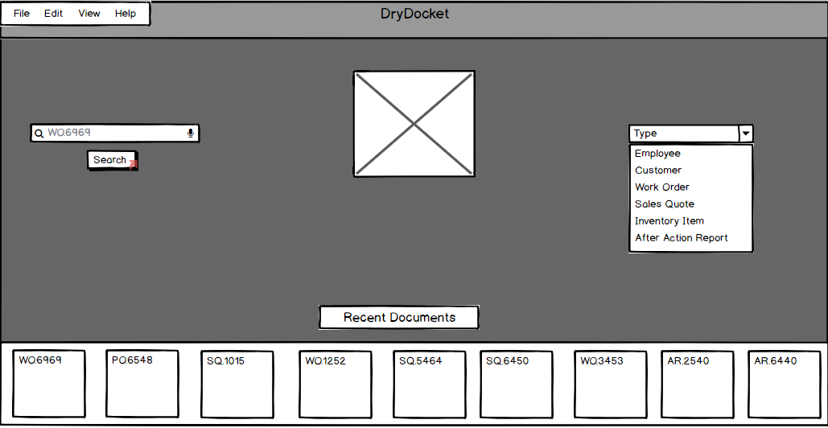

The main search screen is where profiles can be created.They are created in the same way as any other document by selecting the type from the drop down and selecting create.

**Figure 32:** Sequence diagram for Update Customer Profile

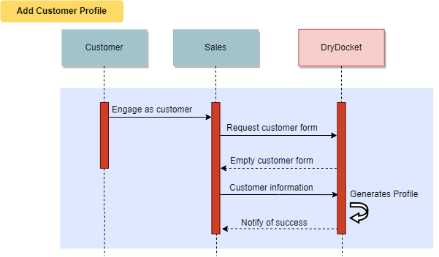

###### Add Employee Profiles

Summary: Allows the Manager to create employees’ profiles.

Actors: Manager

Pre-conditions:

* The employee doesn’t exist in DryDocket.
* The User has logged in.

Post-Condition:

* The employee’s profiles will be added.

Basic Flows:

This use case starts when a new employee starts registration process and enables the Manager to create an account by entering information that’s needed in the employee’s profile.

This should probably be moved to the summary to overall be more consistent with other use cases

Seems like there is a missing step for navigating to the add employee page

* The Manager uploads the employee’s photo to DryDocket (optional).
* The Manager input the employee’s name, address, postal code, email address, phone number, and SIN number to DryDocket.
* DryDocket notifies that the employee profile has been created.

**Figure 33:** Document Creation Screen



See Figure 31.For Document creation description.

**Figure 34:** Sequence diagram for Add Employee Profiles

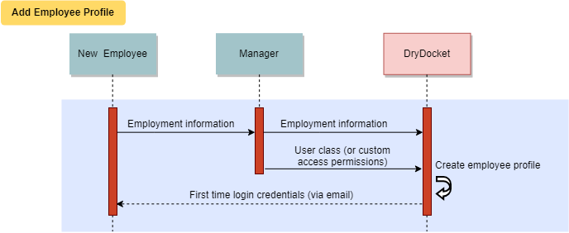

###### Edit Employee Profiles

Summary: Allows the Manager to update the employee’s profile.

Actors: Managers

Pre-conditions:

* The employee exists in DryDocket.
* The editor is logged in.

Post-Condition:

* The employee’s profiles will be modified.

Basic Flows:

This use case starts when the Manager access the employee’s profile and try to update his/her information that’s maintained in the the DryDocket.

* The DryDocket displays fields for the employee form (see *Edit Form Fields* use case) examples include the employee’s name, address, email address, phone number, and SIN number. Having uniquely numbered use cases would make this a lot easier to find
* The Manager enters the desired employee profile information values and requests that the DryDocket saves the entered values.
* The DryDocket validates the entered employee profile information.
* The values for the employee profile that are stored in the DryDocket.
* The DryDocket notifies that the employee profile has been updated.

**Figure 35:** Example Employee Profile

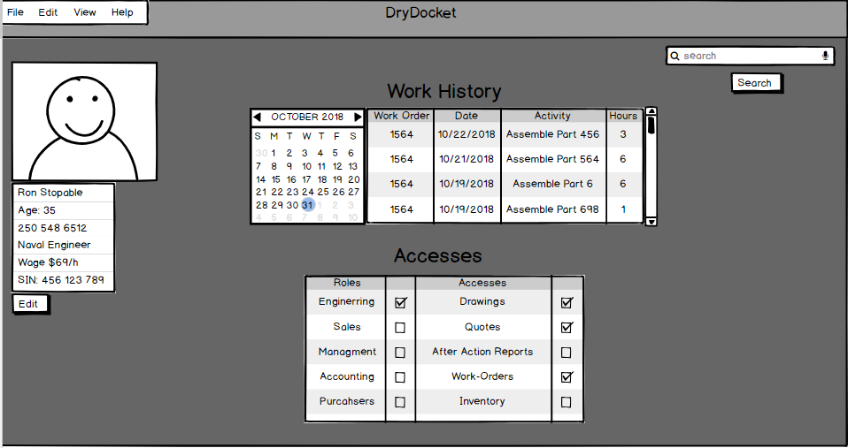

This is an example of an employee profile.It contains their permissions which can be edited from this screen by selecting the boxes.It also contains a history of what the employee has worked on.It also contains basic information about the employee along with a picture. In the whole document, remember to have spaces after periods.

**Figure 36:** Sequence diagram for Edit Employee Profiles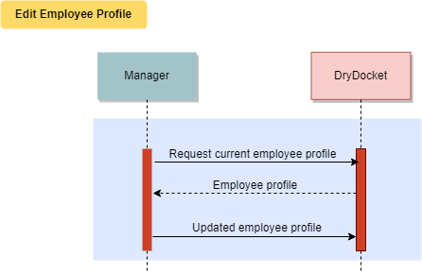

Seems there is a missing step of DD contacting the user with confirmation

### 3.5 Files Upload

#### 3.5.1 Description and Priority

Users of this software will need to be able to upload files to DryDocket.

#### 3.5.2 Functional Requirements

* Engineers are able to upload and link documents to inventory items.
* Purchasers are able to upload files pertaining to inventory items. Should be musts

###### Upload Engineering Documents

Summary: Allows the Engineers to upload specifications documents for the current boat they are producing

Actors: Engineers

Pre-Condition:

* Document is made and ready for upload (not created within DryDocket).
* The User is logged in.

Post-Condition:

* Document will be in the engineering document database.

Basic Flow:

* Engineer completes their document. Already covered by precondition.
* The Engineer access the part’s inventory page.
* The Engineer Edits the document list.

Then what? More steps needed. i.e. select a document, submit.

**Figure 37:** Engineering Document interface

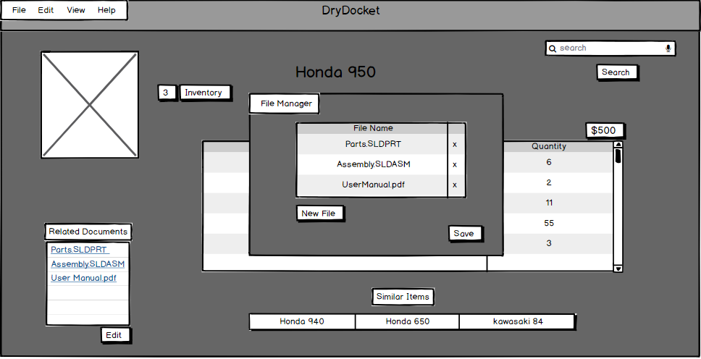

This is the interface to edit the engineering documents related to an inventory item.The database can accomodate any file type.New version can be updated or old files removed by any user with the correct permissions.

**Figure 38:** Sequence diagram for Upload Engineering Documents Inventory Item in diagram below is unclear.

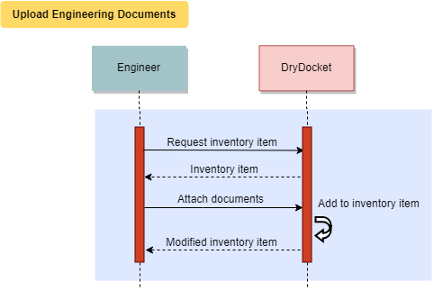

### 3.6 Inventory

###### Resupply Inventory

Summary: Contact Purchasers to resupply missing inventory

Actors: Engineers, Purchasers

Pre-conditions:

* Inventory item is either out of stock or too low of stock for a required Work Order.
* The User has logged in.
* A part is required(rather then specify that an engineer requires a part just make it a precondition, since not only engineers may request parts)

Post-conditions:

* Item is now in stock. Part is now ordered.
* Engineer is updated that the item is now in stock. If you extend this use case to include the part arriving and inventory being updated, you would need to introduce another user class “shipper-receiver” and enlarge your scope. Would suggest you end this use case with “part has been ordered.”

Basic Flow:

* Engineer creates a Parts request and forwards it to a Purchaser.step would be not needed if precondition includes a part is required
* Purchaser contacts Supplier.
* Purchaser orders and receives stock.
* Purchaser notifies Engineer of new stock.

**Figure 39:** Purchaser View of Inventory

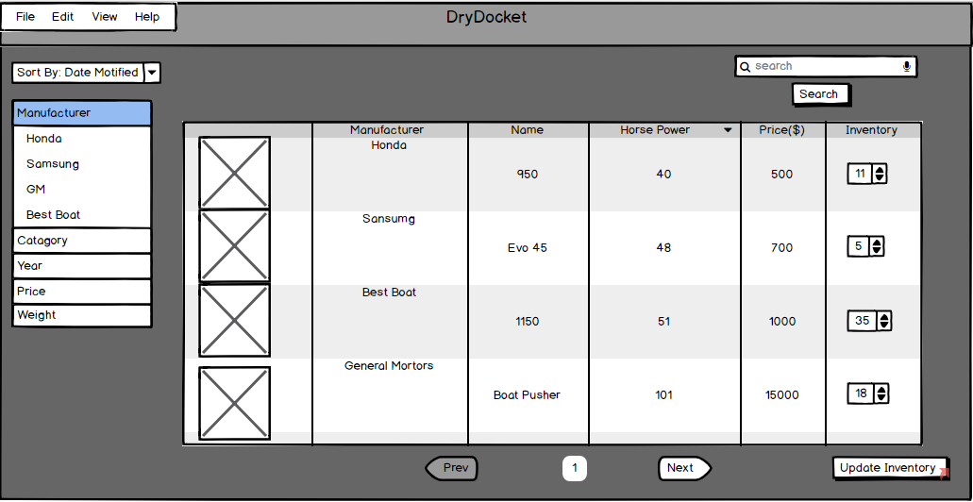

This is the Purchasers view of inventory.They are able to edit the amounts by using the box in the far right column then selecting the button.

**Figure 40:** Sequence Diagram Resupply Inventory

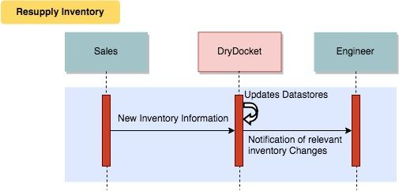

###### Check Inventory

Summary: See if an inventory item is in stock

Actors: Engineers, Purchaser could be any user

Pre-conditions:

* The User has logged in.

Post-conditions:

* None

Basic Flow:

* The User searches for the part.
* The User checks the inventory count. Is the user going to the shop floor to verify the count, or is DryDocket just displaying the count?

**Figure 41:** Example of Default Search View

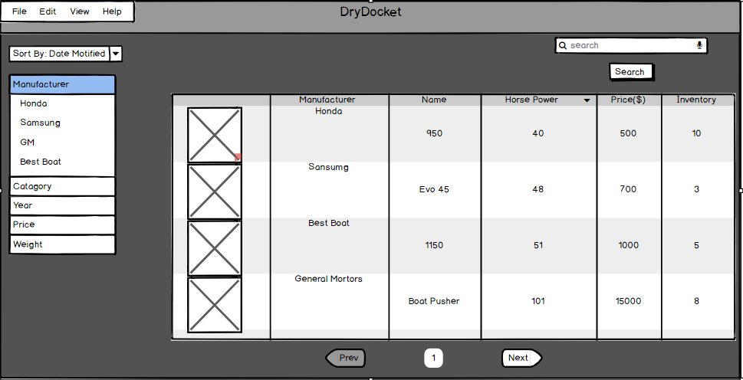

This is the view of a regular search.It shows a variety of columns that can be set by users.This is a default setup but things like lights can be set to show a field about brightness should that be desired. Ambiguous, use more explicit language

**Figure 42:** Example of Detailed Part View

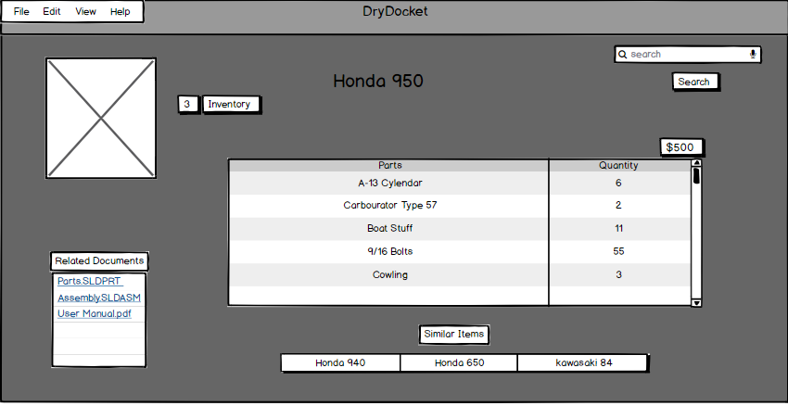

This is an example of a detailed view of a part.This view can be achieved by selecting the picture of something from the default view.This view has the documents relating to the item along with all of the data fields assigned to the item. It also contains links to items that have similar properties.

**Figure 43:** Check Inventory Sequence Diagram

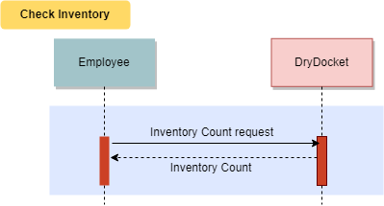

###### Use Inventory Item

Summary: Retrieves an item from inventory and marks it as used in a build

Actors*:* Engineers Unlikely to be engineers updating inventory. Just say “any user with sufficient permissions”

Pre-conditions:

* Item must exist in inventory <<Include "Check Inventory">>.
* The User has logged in.
* A Work Order exists.

Post-conditions:

* The Work Order is updated to show new part counts.
* The inventory count is modified to have the new count.

Basic Flow:

* An Engineer adds the part to a Work Order.
* The inventory count is updated to show a part has been used.

**Figure 44:** Example of Recently Added parts to a Work Order

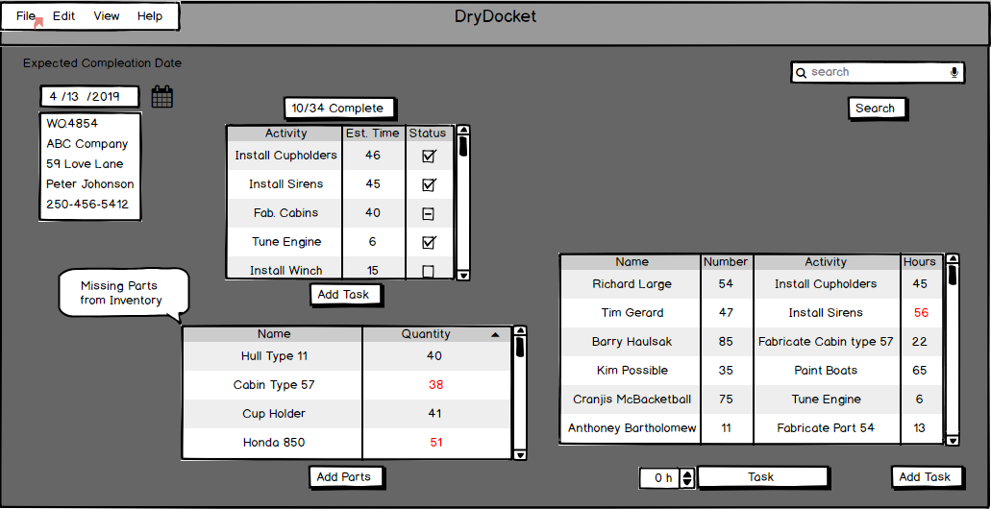

See Figure 5.For Work Order description.

**Figure 45:** Sequence Diagram Use Inventory Item

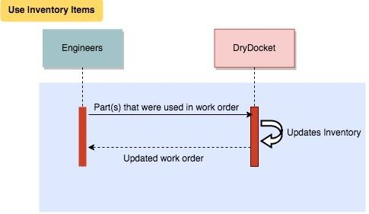

## **4 External Interface Requirements**

### **4.1 User Interfaces**

#### 4.1.1 Interface Accessibility

**ID: EI1 can be referred to by 4.1.1 or use similar formatting to functional requirements**

TITLE: Interface Accessibility

DESC Employees must be able to find menu items with minimal effort.

RAT: By designing the interface to be intuitive employee workflow increases.

DEP: A usable interface.

#### 4.1.2 Interface Dropdown Menus

**ID:EI2**

TITLE: Interface Dropdown Menus (Title is the same in the header, formatting should be reconsidered in all of sections 4 and 5)

DESC Dropdown menus will reduce the amount of manually entered data.

RAT: By using dropdown menus and reducing typing employee workflow will increase.

DEP: Dropdown menus exist on the interface to be used.

#### 4.1.3 Previous Order Template

**ID: EI3**

TITLE: Previous Order Template

DESC: Employees have the option to start a Work Order from an existing template.

RAT: By allowing employees to start a Work Order from an existing template it will drastically increase workflow.

DEP: An existing template of a previous order.

### **4.2 Hardware Interfaces**

DryDocket does not interface with any hardware on the user end.

### 

### **4.3 Software Interfaces**

#### 4.3.1 Backup Data Export

**ID: SI1**

TITLE: Backup Data Export

DESC: DryDocket will be able to export its data into a form compatible with SpeedyBoats current offsite backup system.

RAT: By allowing backup’s to be compatible with SpeedyBoats current system they will not have to replace their backup system

DEP: SpeedyBoats current backup system exists and the data format is the same as DryDocket

### **4.4 Communications Interfaces**

#### 4.4.1 Email Communication

**ID: CI1**

TITLE: Email Communication

DESC: DryDocket is able to export data to email in an intuitive way

RAT: By easily allowing data to be exported to email it will increase the ease at which employees are able to exchange information over email.

DEP: None

## **5 Other Non Functional Requirements**

### **5.1 Performance Requirements**

#### 5.1.1 Concurrent Connections

**ID: NFR1**

TITLE: Concurrent Connections

DESC: DryDocket must support up to 50 concurrent connections with no performance decrease

RAT: In order to allow multiple employees to use DryDocket without noticing slowdown

DEP: No dependencies required should be consistent with above(None)

#### 5.1.2 Form Access Time

**ID: NFR2**

TITLE: Form Access Time

DESC: The time it takes to access to access a form from the database should be less than 5 seconds 5 or one like below?

RAT: The speed at which a form loads?/updates?/saves?/exports? must be kept under one second to reduce workflow slow down and increase the efficiency at obtaining required database information

DEP: An existing form in the database

#### **5.1.3** **Database Search Query**

**ID: NFR3**

TITLE: Database Search Query

DESC: The time it takes to search the database and receive a result should be less than 10 seconds

RAT: The speed at which a database returns a search query should return a result in less than 10 seconds in order to increase workflow efficiency.

DEP: A database must exist to be able to be queried

#### 5.1.4 Employee Profile Creation Usability

**ID: NFR4**

TITLE: Employee Profile Creating Usability

DESC: Adding a new complete employee profile should take 1 hour between creation and completion

RAT: New employees being added to DryDocket should have a fully functional employee profile within 1 hour of beginning to add the employee to a fully complete employee profile

DEP: A database containing employee profiles

#### **5.1.5** **Employee Permission Changes**

**ID: NFR5**

TITLE: Employee Permission Changes

DESC: Permission changes on an employee profile should take effect within 1 minute of being assigned

RAT: Employees permission changes need to take effect within one minute to allow them access to previously non permissible information and increase workflow. And vice versa (to disallow employees from accessing information they should not have access to to increase security)

DEP: An existing employee profile

#### **5.1.6** **Form Autofill**

**ID: NFR6**

TITLE: Form Autofill

DESC: When inputting text on a document the autofill should instantaneously suggest options to select

RAT: By instantaneously suggesting autofill options this will reduce the time needed to employees to type out tedious information extraneous

DEP: A form currently being worked on

### Replace instantaneous with a testable value

### **5.2 Safety Requirements**

#### 5.2.1 Previous Interface Backup System

**ID: NFR7**

TITLE: Previous Interface Backup System

DESC: DryDocket will interface with the previous backup system of E2, to be able to recover previous backups

RAT: By interfacing with the previous backup system E2, data will be able to be recovered and used by DryDocket.

DEP: The existence of backups used on the prior E2 system.

#### 5.2.2 Off-Site Backup (Consistency in spelling of offsite)

**ID: NFR8**

TITLE: Off-Site Backup

DESC: DryDocket will backup to an off-site server every 5 hours

RAT: By backing up off site, DryDocket will be able to store and recover information in the case of a failure

DEP: An off site server that accepts backups

#### 5.2.4 Unique Backup File

**ID: NFR9**

TITLE: Unique Backup File

DESC: DryDocket will store each backup as a unique file

RAT: By storing each backup as a unique file, DryDocket will be able to recover from numerous different points.

DEP: A off-site server that accepts backups

### **5.3 Security Requirements**

#### 5.3.1 Part Diagram Access Permissions

**ID: NFR10**

TITLE: Part Diagram Access Permissions

DESC: DryDocket will only allow users with the Engineer role to access part diagrams Consider putting “users with permissions”

RAT: By allowing only Engineers to access part diagrams it satisfies permission requests as laid out by SpeedyBoats. Request was that only engineers can *edit* part diagrams. Other user classes will need read-only access

DEP: A part diagram with access permissions assigned

#### 5.3.2 Gaining Access to DryDocket

**ID:NFR11**

TITLE: Gaining Access to DryDocket

DESC: How DryDocket users will authenticate themselves

RAT: By ensuring all users of DryDocket are authenticated with a password and employee number it will satisfy the security requirement as described by SpeedyBoats

DEP: An active version of DryDocket

#### 5.3.4 Captured Data Confidentiality

**ID: NFR12**

TITLE: Captured Data Confidentiality

DESC: DryDocket will encrypt all stored data with AES-256 only ever used here, perhaps state the full abbreviation of AES and describe

RAT: By encrypting all stored data this reduce breaches of confidential information

DEP: Existing files within DryDocket~~s~~

#### 5.3.5 File Deletion

**ID: NFR13**

TITLE: File Deletion

DESC: DryDocket will only allow users with Engineer or Management permissions the ability to delete files Consider putting “users with permissions”

RAT: By only allowing users with Engineers or Management permissions the ability to delete files the security of the files satisfies SpeedyBoats permission requests

DEP: Existing files within DryDockets, users with Engineer or Management permissions

#### 5.3.6 Role Management

**ID: NFR14**

TITLE: Role Management

DESC: DryDocket will only allow Managers to change the view and edit permissions of employees

RAT: By only allowing users with Management permissions the ability to change permissions the security of the files satisfies SpeedyBoats permission requests

DEP: Active employees within DryDocket and at least one with a Manager role

#### 5.3.7 True Cost Analysis

**ID: NFR15**

TITLE: True Cost Analysis

DESC: DryDocket will only allow purchasers,accountants and Managers to see the true cost of inventory Consider putting “users with permissions”

RAT: This information is highly confidential to SpeedyBoats and was a requirement from SpeedyBoats that this information be restricted

DEP: Existing files within DryDockets

### 

### **5.4 Software Quality Attributes**

#### 5.4.1 Application Portability

**ID: SQ1**

TITLE: Application Portability

DESC: DryDocket must be able to run on all internet browsers with version of 2015 or later

RAT: DryDocket needs to be compatible with all browsers to allow compatibility with any operating system

DEP: Web Browser with a version of 2015 or later

#### 5.4.2 Availability During Updates

**ID: SQ2**

TITLE: Availability During Upgrades

DESC: DryDocket will not be available during upgrades for a period of UP TO 12 hours

RAT: DryDocket will have transition downtimes of UP TO 12 hours during upgrades. This will allow DryDocket to begin upgrades at the end of a work day (8pm) and be available again by the morning (8am)

DEP: None

#### 5.4.3 DryDocket Failover

**ID: SQ3**

TITLE: DryDocket Failover

DESC: DryDocket if for any reason fails will be back online within 1 hour

If Drydocket fails for any reason if will be back online within 1 hour

RAT: By having a 1 hour or less turnaround time of a complete system reboot from a backup DryDocket aims to reduce workflow disruptions

DEP: An existing backup of DryDocket to reboot from

## 

## **6** Additional R**equirements**

New users must be able to obtain basic proficiency with less than 4 hours of training. Basic proficiency means that the users knows how to complete all the tasks that arise from common use of the software but may need assistance in more advanced tasks.

The database is able to migrate to a new environment while remaining operational. It can take a long time to fully transfer a database to a new location, it would be unacceptable if the data was unavailable during this process. 5.4.2(sq2) mentioned 12 hour downtime, that is reasonable, this requirement may need change

## **7 Analysis Models**

All use cases below assume the user and their device have valid authentication for DryDocket. If the device is not yet authenticated, DryDocket redirects them to a login page where they provide their credentials before continuing. Credentials are erased on logout.

### **7.1 Use Case Model** (spelling of Boundary)

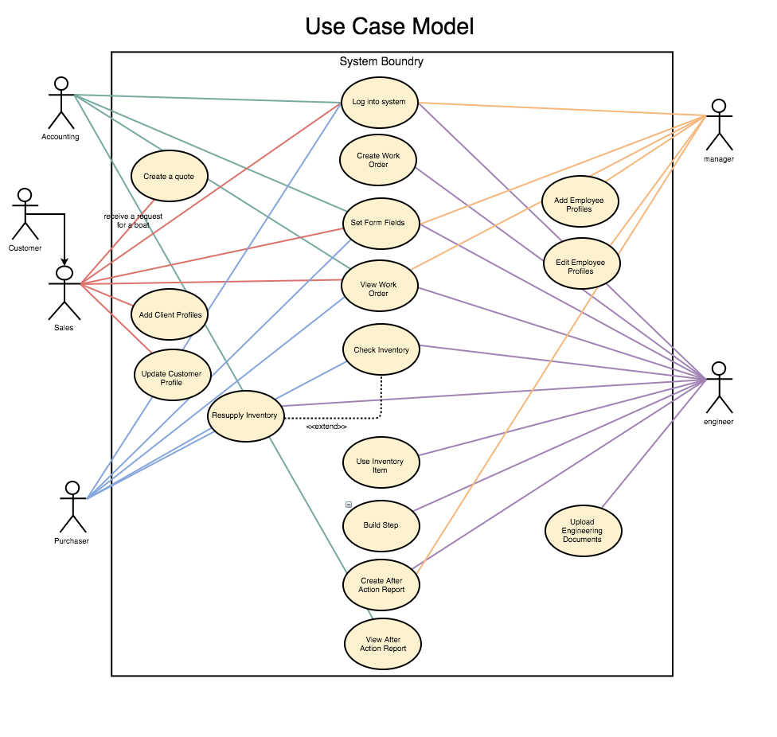

Use case model describes the proposed functionality of DryDocket system. Each bubble represent a single use case, and each use case represents the interaction between our potential users and the DryDocket system. (Use cases are specified in Section 3: DryDocket Features)

Note: There is an actor-to-actor relationship because Customer exists in our use cases but does not directly interact with our system.

### 7.2 Entity Relationship Diagram

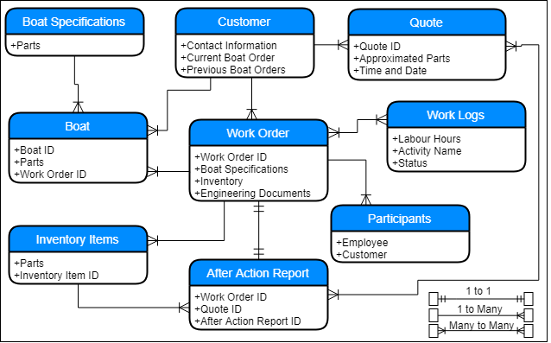

Entity relationship diagram describes the proposed relationships that each entity will be connected to with the DryDocket system. Each bubble has the name of the entity with the attributes that pertain to that entity.

Boat is a design, design should loop on itself since it can contain designs and parts. Boat and boat specification entity is unneeded. Design can contain parts and other designs, as per comments on page 1

Quote - should link to to Work Order (1 or 0 to 1), and the link to After Action Report should not be Many to Many - it should be 1 or 0 to 1. (IE: sometimes a quote will yield one After Action Report, but not all quotes will)

### 

### 7.3 Data Flow Diagrams

#### 7.3.1 [DFD 0] Why brackets?

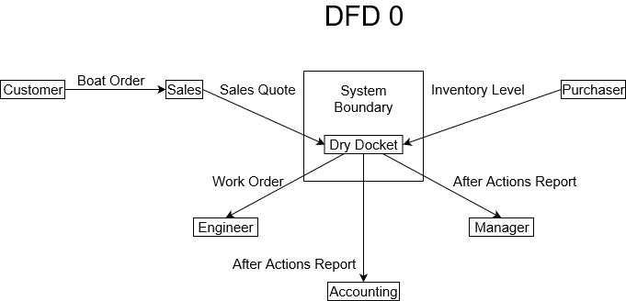

DFD 0 illustrates what each user, on a high level, provides or receives from DryDocket. After receiving an order from a Customer, Salespersons provide Sales Quotes, Purchasers stock Inventory, Engineers receive Work Orders, and Accountants and Managers receive After Action Reports.

Data should flow to and from each actor. Each arrow should flow both ways with a description of data.

#### 

#### 7.3.2 [DFD 1]

**Consider reworking the DFD diagrams after the document edits are completed.**

**Each dataflow arrow should be doublesided and contain descriptions for data going both ways. Labels on arrows should signify data.**

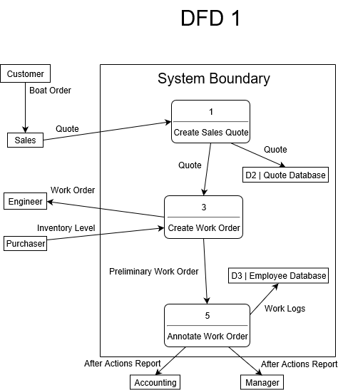

DFD 1 expands on the main process in the DryDocket software. Salespersons create Sales Quotes, which causes the system to create a Work Order for Engineers to use. Purchasers monitor inventory as necessary, and then the system completes the Work Orders to log employee hours and provide After Actions Reports for Accounting and Management.

#### 

#### 7.3.2 [DFD 2]

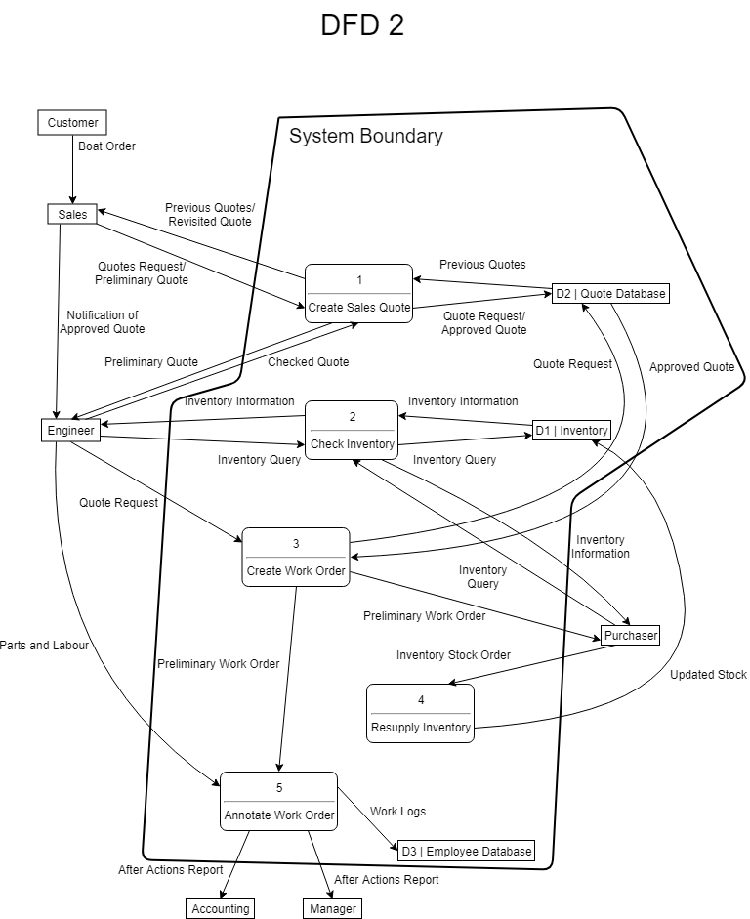

DFD 2 expands on the complex data flow in each previous step of the main software process. Salespersons may use previous quotes as a reference, and send a preliminary quote to Engineers via the software. Engineers can view pricing of inventory parts to help them decide whether to approve the Salespersons’ quotes, or send them back to Salespersons for review. This process repeats until Engineers approve of the quote, in which case it will be finalized by Salespersons and stored in the Quote Database.

Once the quote is finalized, Salespersons will notify the Engineers (via means outside of the system such as email). Engineers will then review the finalized quote and create a Preliminary Work Order via the software. The Preliminary Work Order is sent to the Purchaser to resupply on inventory as necessary, and then annotated by the software.

After annotating the Work Order, the system stores employee Work Logs for salary management and provides Accounting and Management with an After Actions Report.

### 7.4 Data Dictionary

No explanation is given as to what this is.

|  |  |
| --- | --- |
| activity-name | ::= 1{alphanumeric}25; |
| address | ::= street-address, city, province, postal-code; |
| after-action-report | ::= work-order-ID, quote-ID, after-action-report-id, labour-breakdown, parts-used, true-cost; |
| after-action-report-ID | ::= 1{digit}; |
| age | ::= 1{digit}3; |
| alphanumeric | ::= “a” … “z” | “A” … “Z” | “0” … “9” | “-” | “‘“ | “.”; |
| approximated-parts | ::= part-name, part-quantity, price-per, total; |
| boat | ::= boat-ID, parts, work-order-ID; |
| boat-specifications | ::= parts; |
| boat-ID | ::= 1{digit}10; |
| city | ::= 1{alphanumeric}; |
| company-name | ::= 1{alphanumeric}; |
| contact-information | ::= phone-number, POC-name, email; |
| customer | ::= company-name, address, contact-information, postal-code, image, {work-order}; |
| date | ::= month, “/”, day, “/”, year; |
| day | ::= “01” .. “31”; |
| email | ::= 1{alphanumeric},”@”,1{alphanumeric}; |
| employee | ::= name, age, phone-number, role, wage, SIN, image; |
| engineering-document | ::= {image}; |
| image | ::= {BLOB}; |
| labour-breakdown | ::= employee, part-quantity, completed-task, labour-hours; |
| labour-hours | ::= 1{digit}; |
| month | ::= “01” .. “12”; |
| name | ::= 1{alphanumeric}25; |
| participants | ::= employee, customer; |
| part-name | ::= 1{alphanumeric}10; |
| part-picture | ::= {image}; |
| part-quantity | ::= 1{digit}3; |
| parts | ::= part-name, part-quantity, part-picture; |
| parts-used | ::= part-name, part-quantity; |
| phone-number | ::= digit, “-(”, 3{digit}3, “)-”, 3{digit}, “-”, 4{digit}4; |
| POC-name | ::= 1{alphanumeric}25; |
| postal-code | ::= 6{alphanumeric}6; |
| price-per | ::= {digit}; |
| profit | ::= “$”, 1{digit}7; |
| province | ::= 1{alphanumeric}; |
| quote | ::= quote-ID, date, approximated parts, customer; |
| quote-ID | ::= “SQ.”, 4{digit}; |
| role | ::= 1{alphanumeric}25; |
| SIN | ::= 9{digit}9; |
| status | ::= “1” | ”-1” | ”0”; |
| street-address | ::= 1{alphanumeric}; |
| total | ::= {digit}; |
| true-cost | ::= quoted-price{total}, part-quantity, labour-hours, profit; |
| wage | ::= “$”, 1{digit}4; |
| work-logs | ::= labour-hours, activity-name, status; |
| work-order | ::= work-order-ID, specifications, inventory, engineering-document; |
| work-order-ID | ::= 1{digit}7; |
| year | ::= {digit}4; |

## **Appendix: Issues List**

A scheduling system was discussed with SpeedyBoats but negotiations are still underway as to whether or not this is a desired feature.

## 